

**UNIVERSITY OF PETROLEUM & ENERGY STUDIES**

**SCHOOL OF COMPUTER SCIENCE**

***Department of Cybernetics***

**GRAPHICS AND ANIMATIONS TOOLS**

LAB FILE

SESSION(2020-21)

Course: BTech with specialization in Open Source & Open Standards

Submitted to: Submitted by:

Dr. Durgansh Sharma Surabhi Kumari

Associate Professor SAP ID: 500063663

Department of Cybernetics Roll no: R100217101

**Experiment 1:** Installation of GIMP and Blender

**GIMP Installation**

Step 1**:** Download the GIMP installer free from gimp.org/downloads

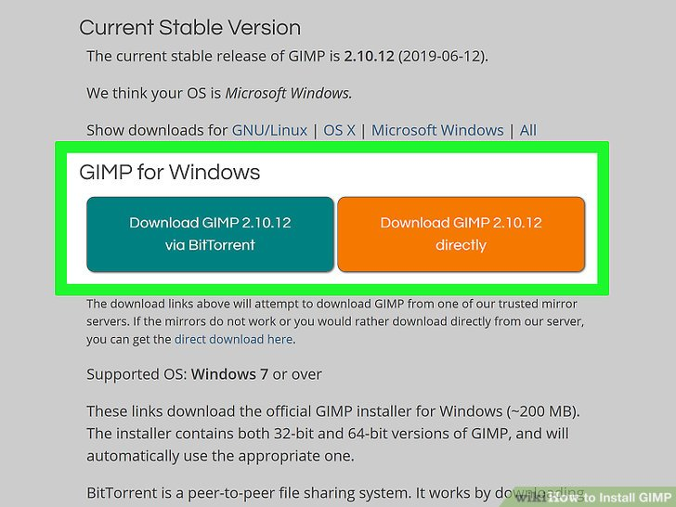

Step 2: Installation of GIMP 2.10 will require downloading of the package from the official website of GIMP i.e. [www.gimp.org](http://www.gimp.org) (GNU Image Manipulation Program).

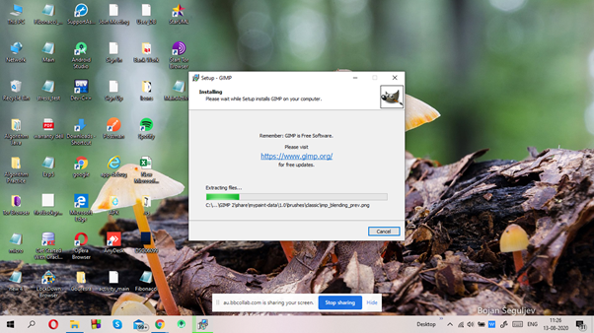

Step 3**:** Follow the prompts to install GIMP. Most users can leave the settings at the defaults

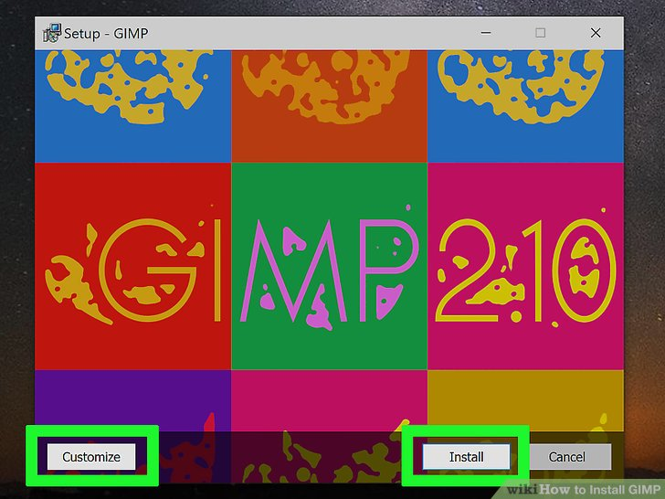

Step 4: Installing GIMP using the setup wizard.

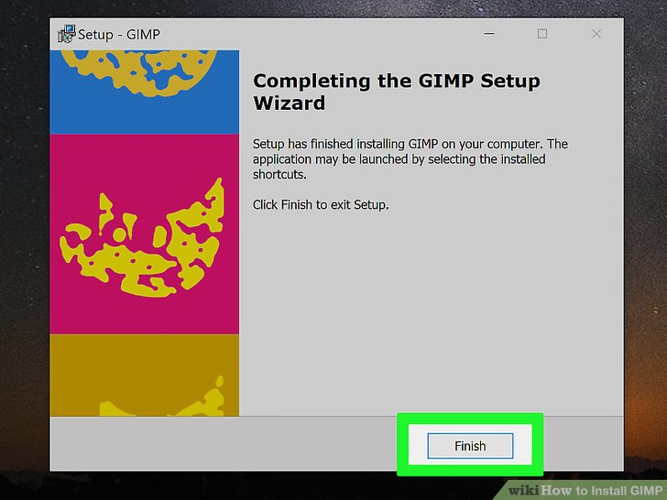

Step 5: Loading of the user interface of GIMP.

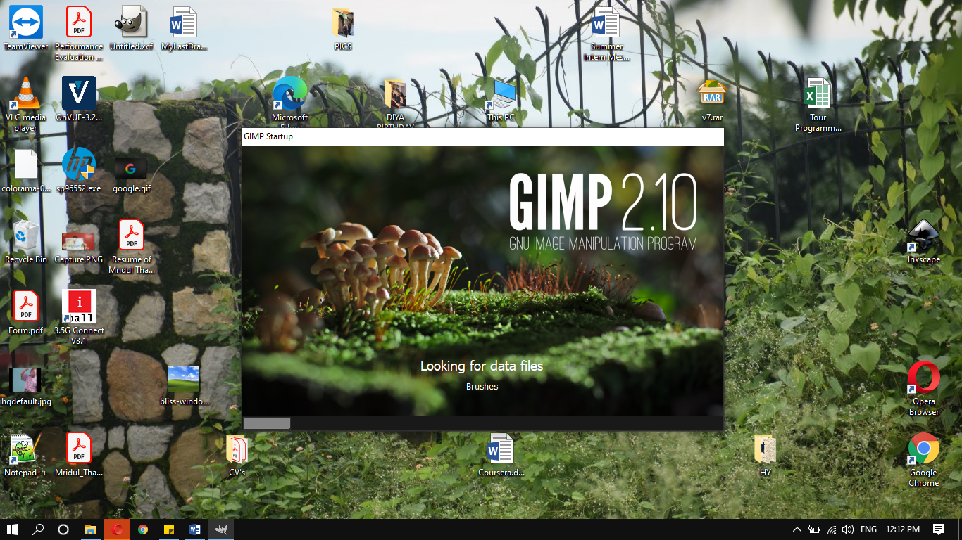

Step 6: The user interface of GIMP

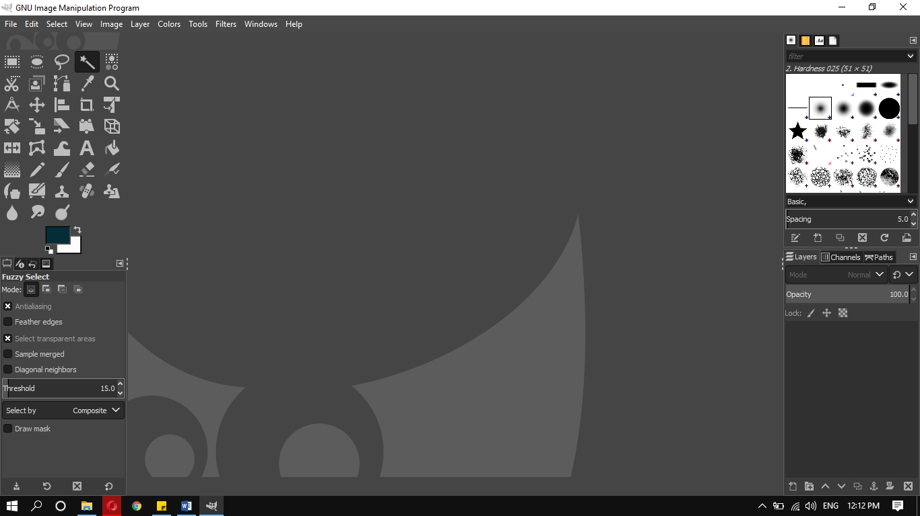

**Blender Installation**

Step 1: Installation of Blender Package Installer downloaded from [www.blender.org/download](http://www.blender.org/download)

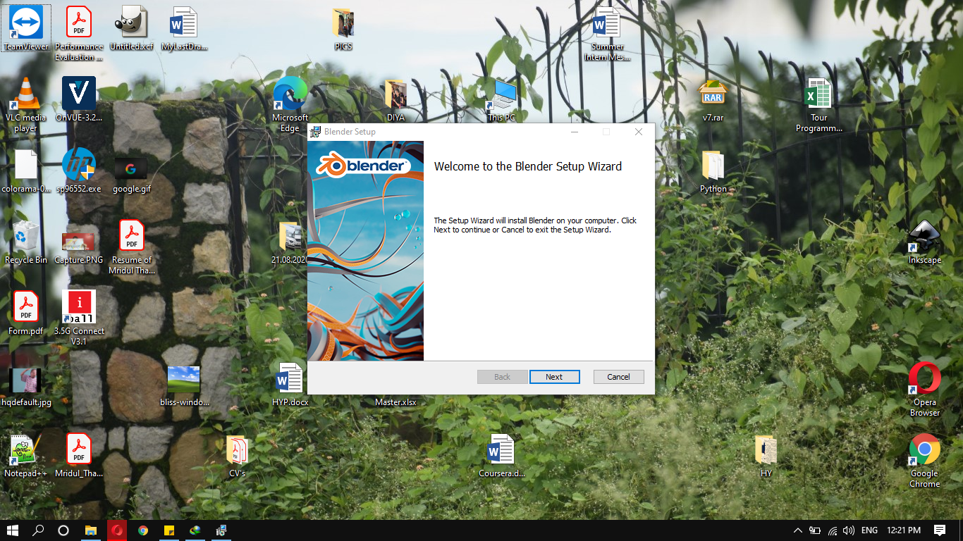

Step 2: Accepting the user-agreement.

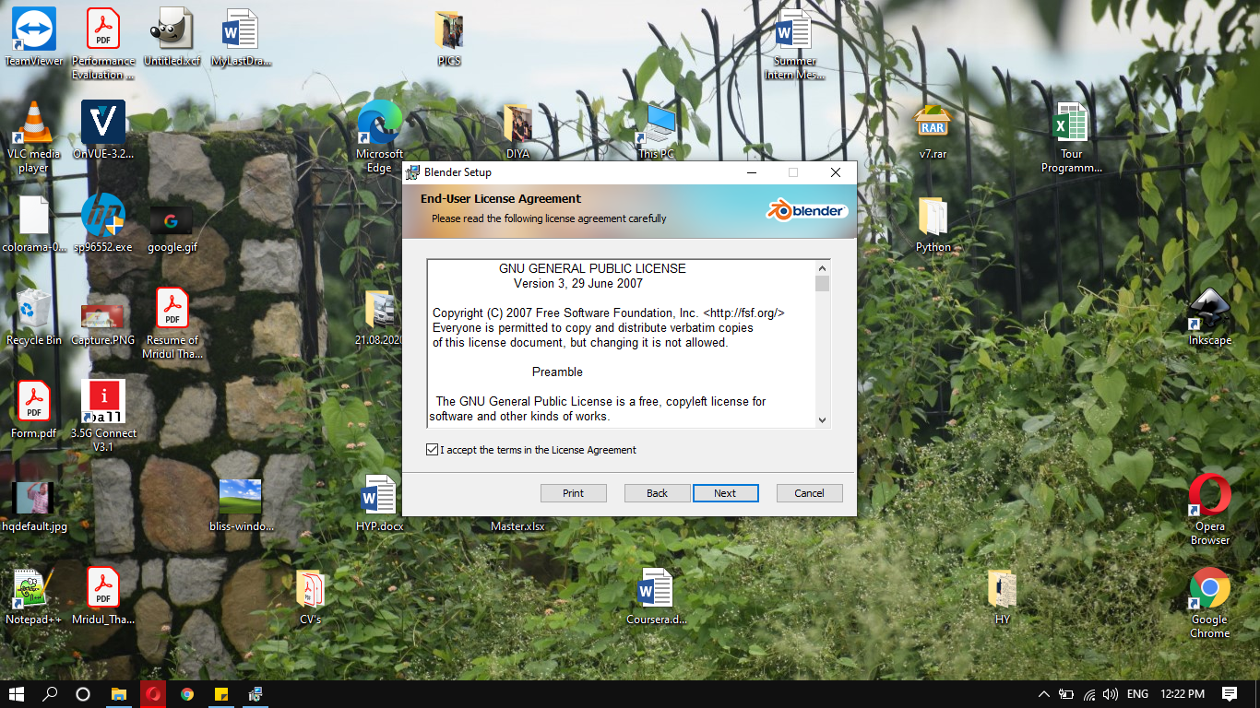

Step 3: Installing Blender, set Custom path if you want to or leave it at default location.

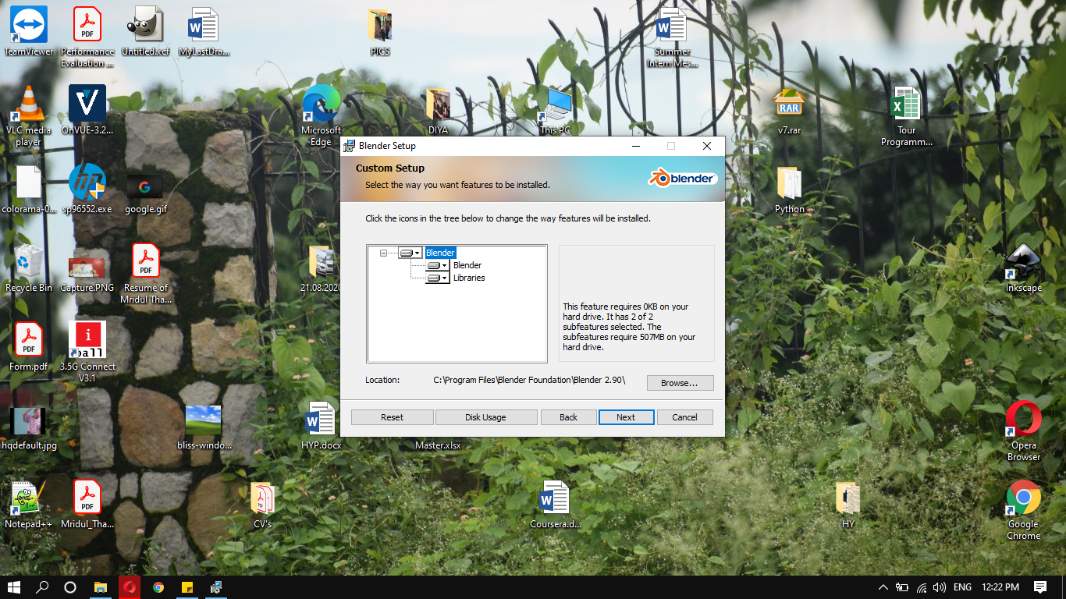

Step 4: Completion of the setup.

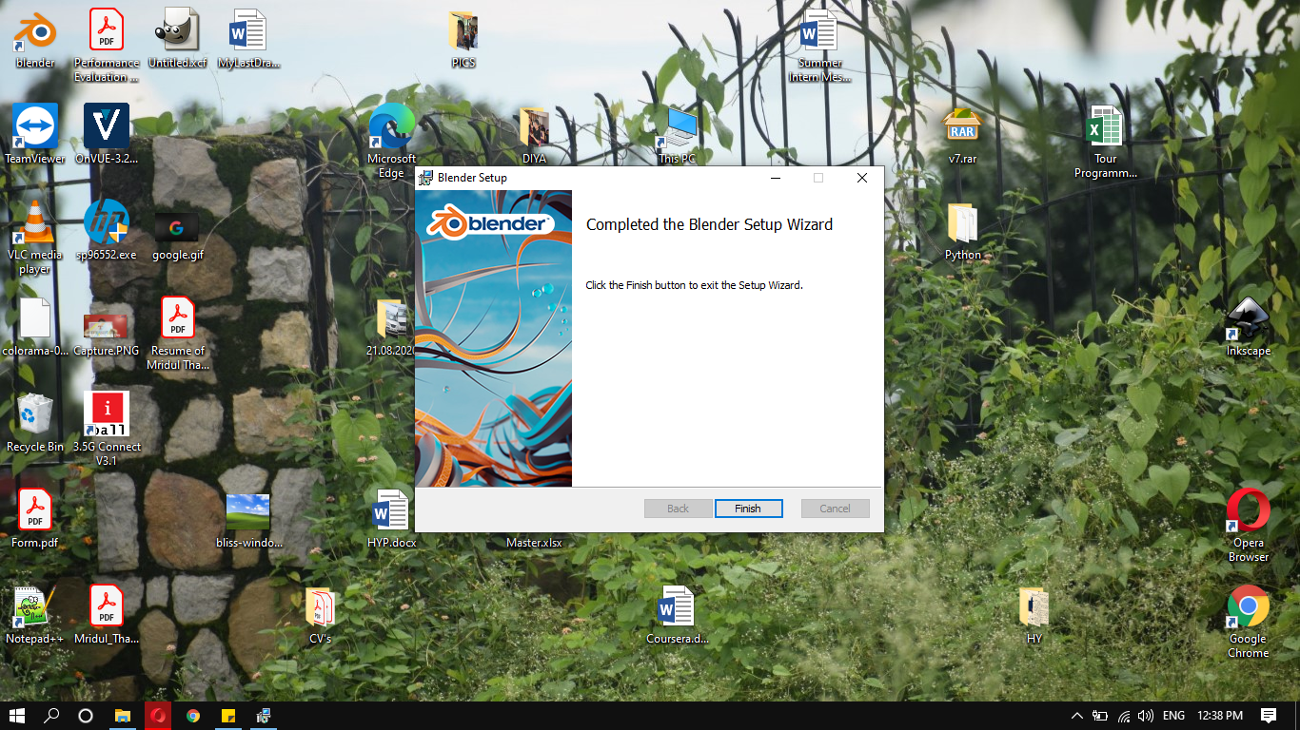

Step 5: The user interface of Blender.

